NAME: SACHIN HANSDA
ROLL NO.: 111601019
DBMS LAB 4

1. Create another view stud_cred containing ID, name and tot_cred of the students.
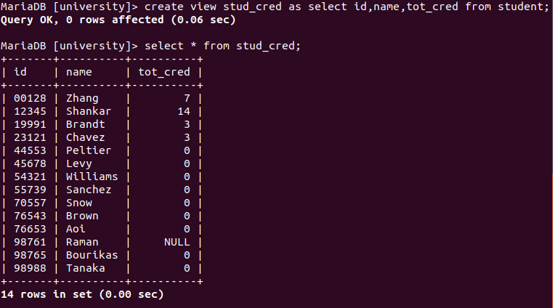

1.a. Remove ‘Tanaka’ from stud_cred. Show effect on stud_cred and student.
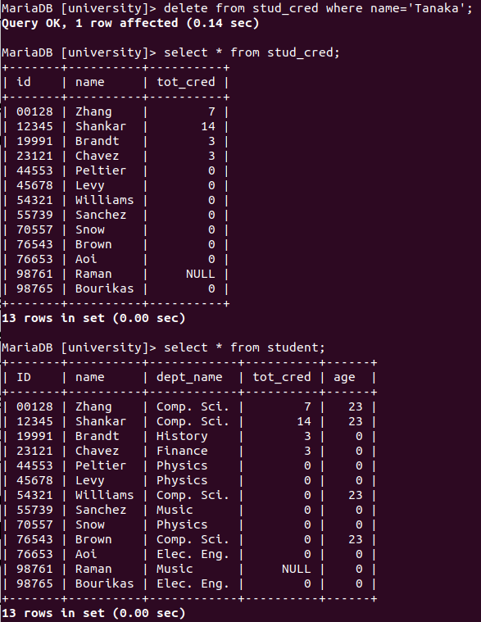
1.b. Insert Tanaka back into stud_cred. Show effect on stud_cred and student.
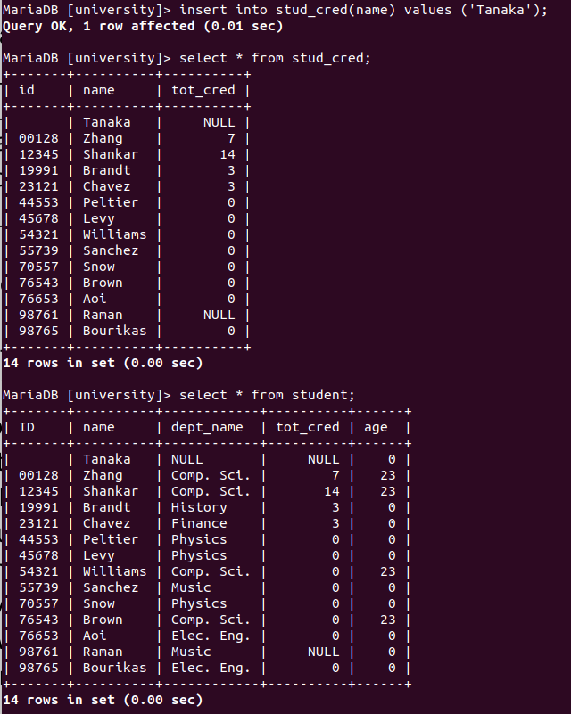

2. List down the views in the current database. Check the view that you created last week -
stud_dept_budg, if it is not present create it again.
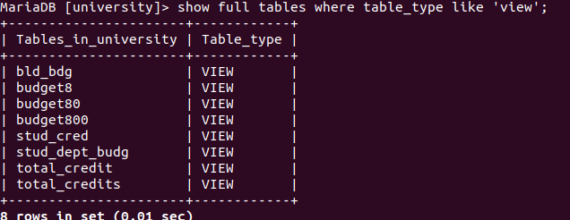
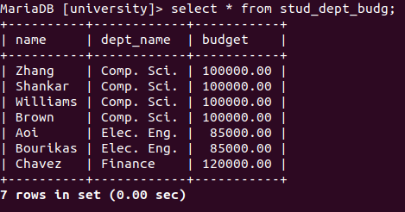

2.a. Remove ‘Zhang’ from stud_dept_budg view. Show effect on stud_dept_budg and
student.
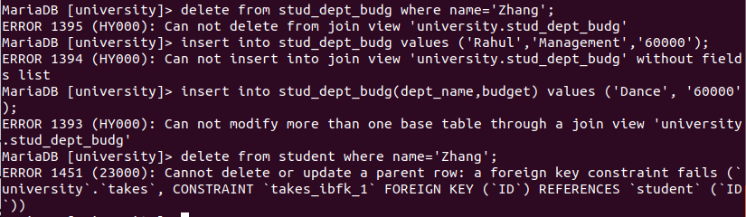

2.b. Insert (Rahul, Management, 60000 ) into stud_dept_budg.
2.c. Insert (Dance, 60000 ) into stud_dept_budg.

2.d. Delete Zhang from student table. Show the effect in stud_dept_budg view.
3. Modify department table add default value for dept_name as NULL.
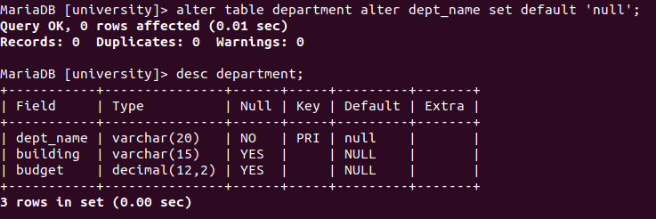
4. Modify department table drop default value for dept_name.
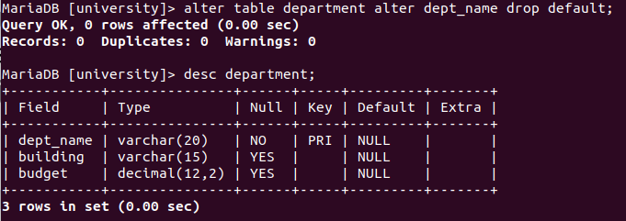
5. Create a view bld_bdg containing building and budget from department table.
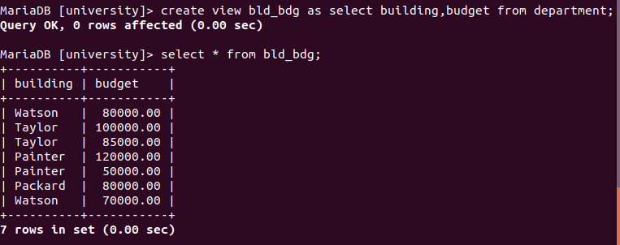

6. Create user tom with login process using password iamtom. Then give tom permission to
see content of bld_bdg. Login as tom, check list of tables and views, content of student
and department table and bld_bdg view.
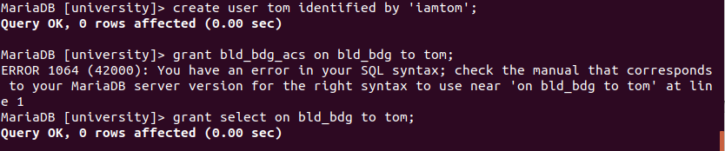
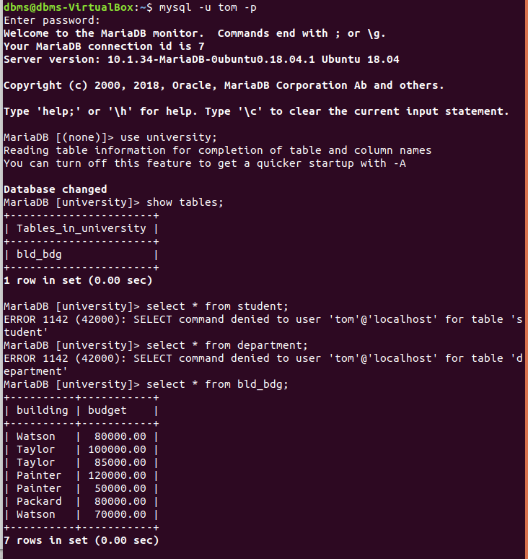

7. Create user jerry to login with password iamjerry. Then give tom permission to see
content of student table. Login as jerry, check list of tables and views, content of student
and department table.
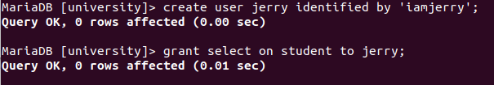
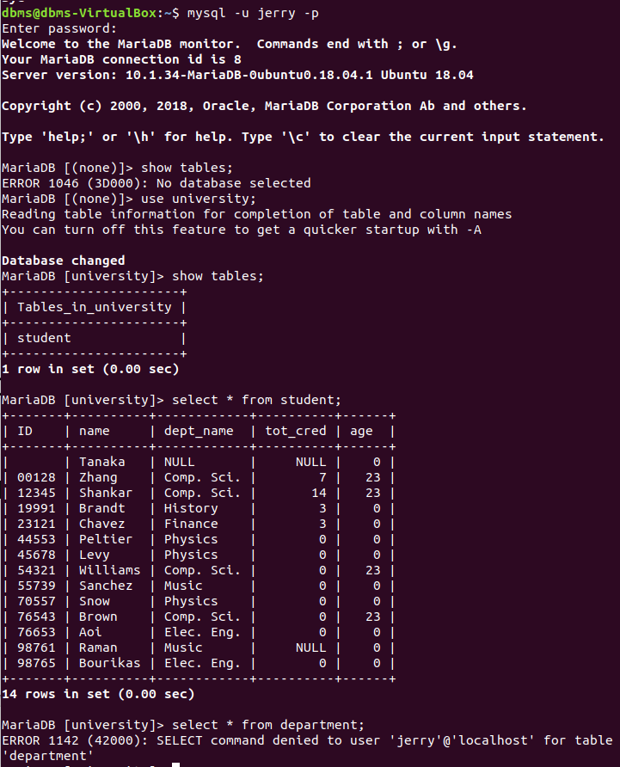
8. Delete tom and jerry.
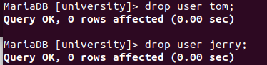

9. Create role see_students. Give select permission to see_students for stud_cred view.
Create user tom with password as above. Assign see_students role to tom. Log in as
tom and list the tables and content of the student table and stud_cred view.
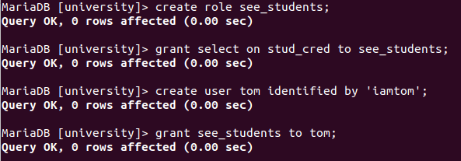

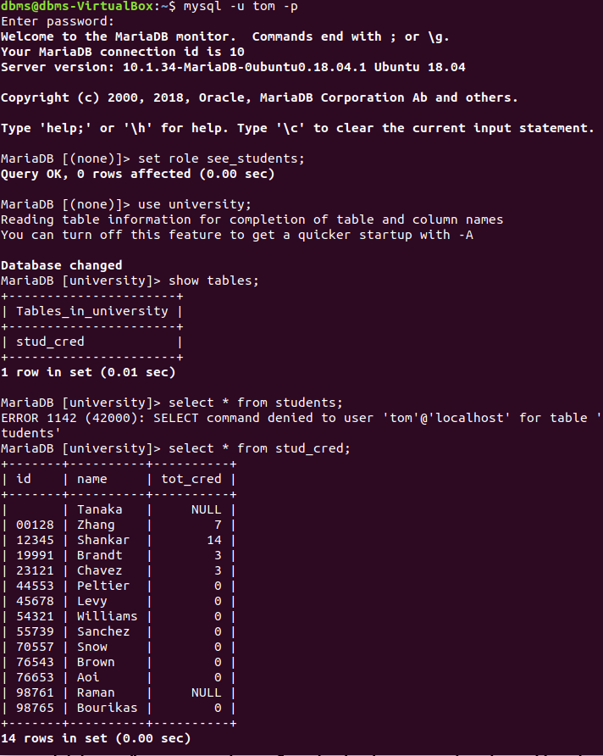

10. Create role see_instructors. Give select permission to see_instructors for instructor
table. Assign see_instructors role to tom. Log in as tom and list the tables and content of
the instructor and student table.
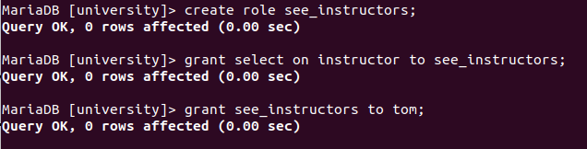
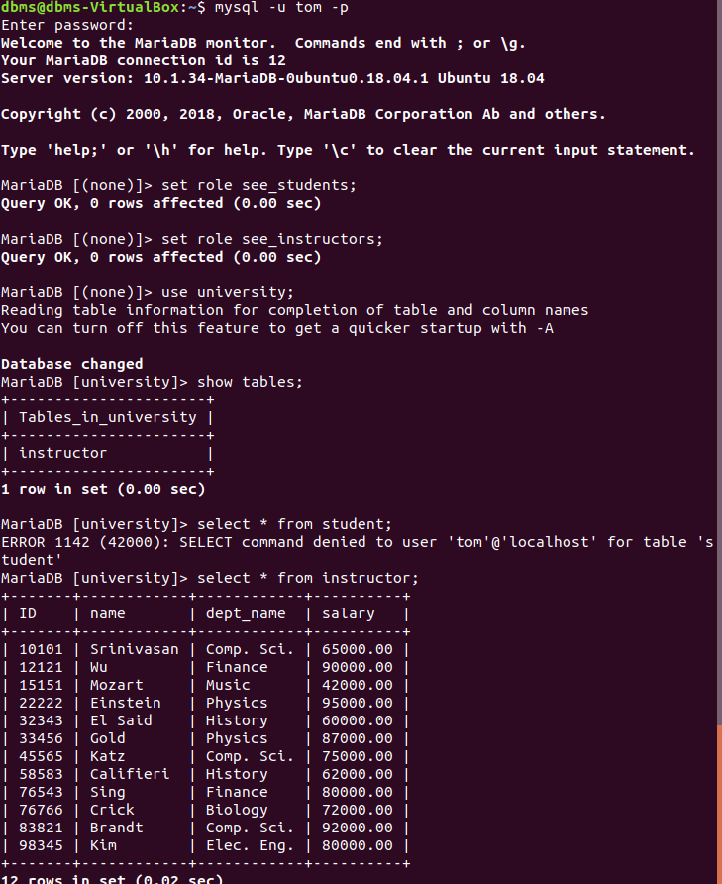
11. Withdraw see_students and see_instructos role from tom.
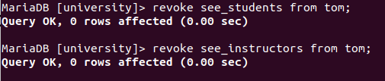

12. Create two admin roles: admin1, admin2. Give privilege to admin1 and admin2 to view
content of department table. admin1 and admin2 will also to be able to give other users
the same privilege.
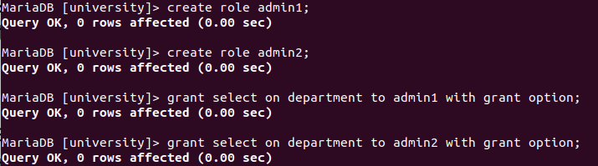
13. Create a user jerry with password iamjerry. Create a user nibbles with password
iamnibbles. Assign admin1 role to tom and admin2 role to jerry.
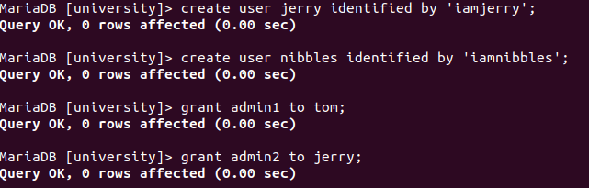
14. tom and jerry should set role as admin1 and admin 2. Then independently they give
privilege to nibbles to see content of department table.
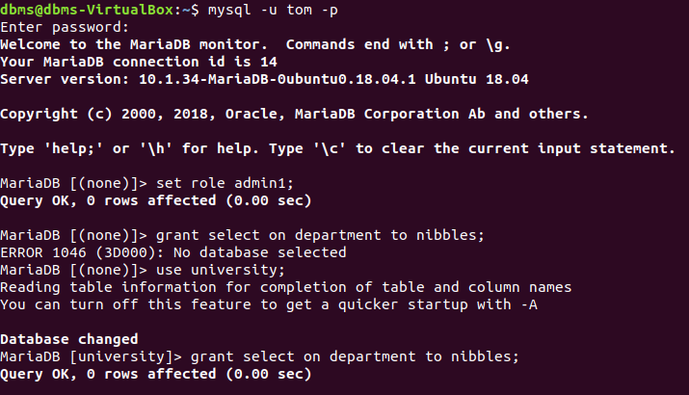

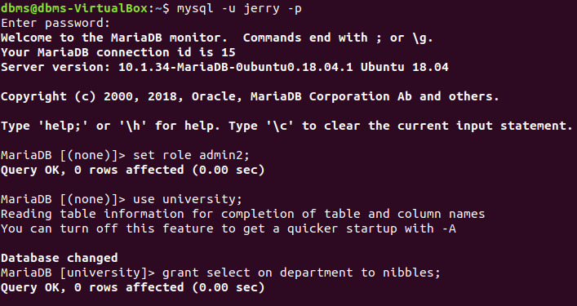
15. Login as nibbles. Go to university database and list the records from the department
table.
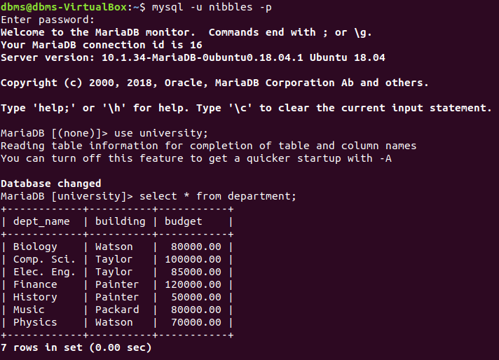

16. Login as jerry. Remove select privilege from nibbles.
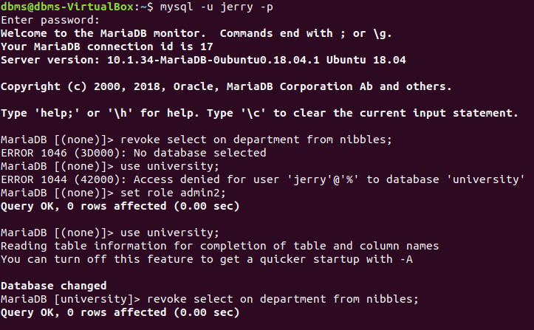
17. Login as nibbles. Go to university database and list the records from the department
table
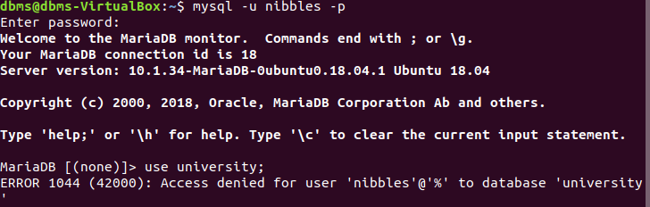
18. Login as tom. Give select privilege to nibbles for department table.
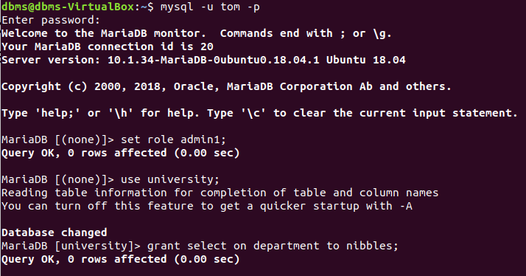
19. Login as nibbles. Go to university database and list the records from the department
table.
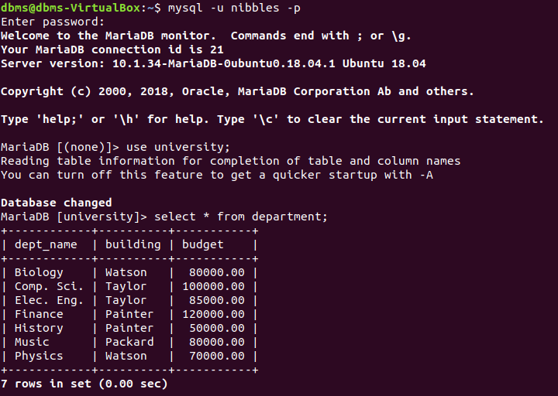
20. Login as root. Release tom from admin1 role
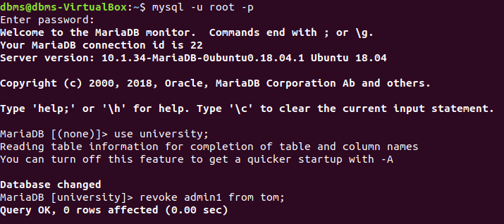

21. Login as tom. Go to university database and list the records from the department table.
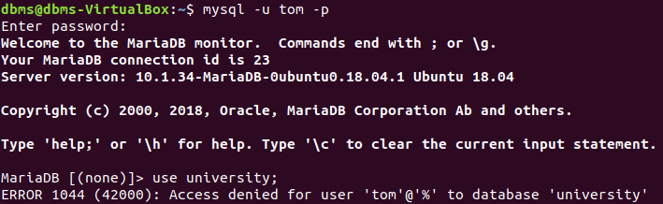
22. Login as nibbles. Go to university database and list the records from the department
table.
